**Background Images**- Use the images from the site linked from my google classroom (these are web safe images) Using a regular picture from google as background is BAD practice.

EVERY SINGLE computer/smartphone/tablet in the world has a different screen size than you’re current computer. It may look good on your computer, but not the one Mr. K uses to grade your projects.

* 1. **To save:** Find the image on the site provided. Right click > save image as > save to the **CURRENT** assignment’s root folder, inside the image folder

1. 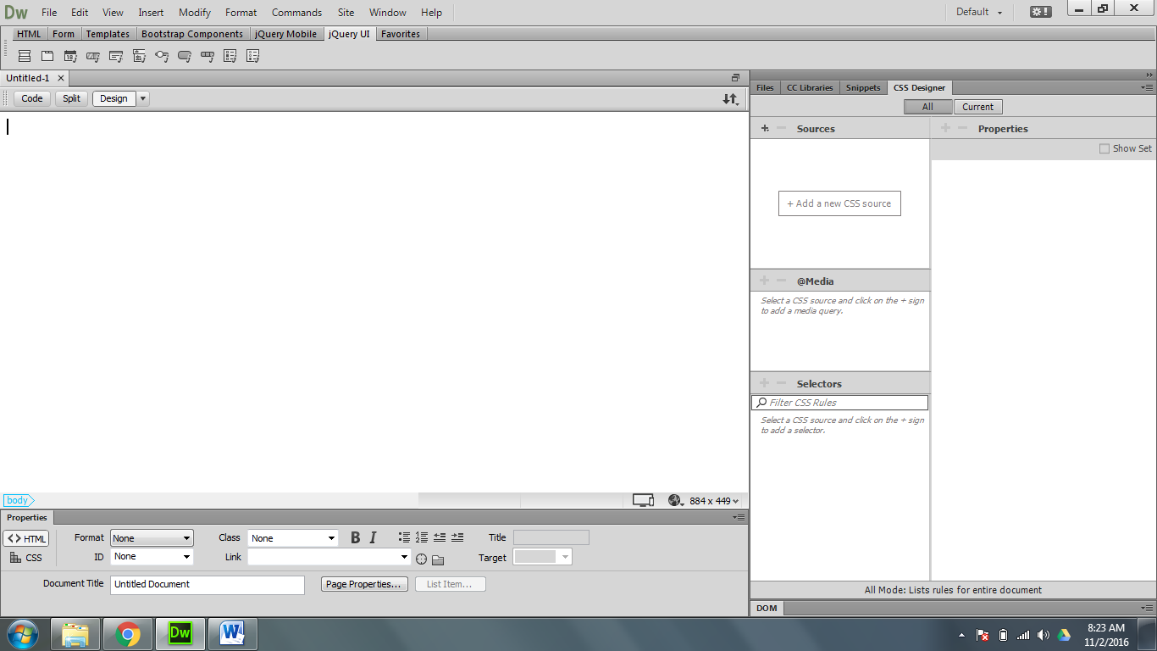Click on Page Properties

3

1. 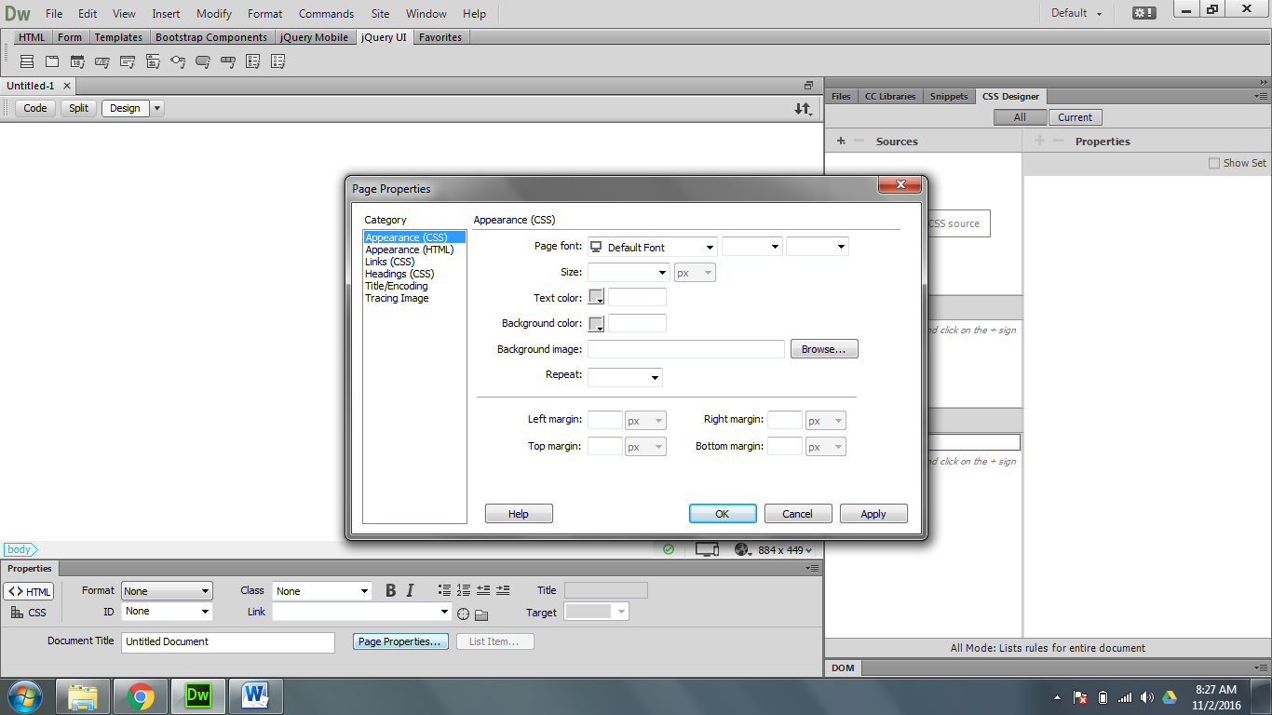BACKGROUND: Insert a picture background
   * 1. Click on _Browse________
     2. locate your image in the *___current root folder’s image folder _____*
   1. Select a background color:
      1. Click on the background color block
      2. click on the eyedropper , and click on a part of the background to ‘sample’ that color to create a color theme
   2. Repeat
      1. Repeat: fills the screen with the image
      2. Repeat X: ___Left to right _______
      3. Repeat Y: ___Up and down______
   3. Margins: ____Will offset the content on the page (10-45 px margin is usually standard)_
      1. ~~Left - IGNORE~~
      2. ~~Right- IGNORE~~
      3. Top- Creates space from top of web browser and top of website. This number needs to be consistent across every page.
      4. Bottom- if want some extra space below the page, add some here